**ERP Implementation for Production Planning Improvement**

**1. Introduction**

This report analyzes the inefficiencies in the current production planning process of an agricultural chemicals company and proposes an Enterprise Resource Planning (ERP) solution to optimize operations.

**2. Current Production Planning Process**

At the end of each month, the company manually collects orders and inputs them into its production planning system. Data from the previous month’s production and inventory records are also manually entered. Analysts from sales and production departments estimate sales and production targets, which often do not align. A senior management meeting is held to reconcile these differences and finalize the master production schedule.

**2.1 Process Flow (Current System)**

1. Orders are compiled at the end of the month.
2. Manual entry of production and inventory data.
3. Sales department analyzes sales forecasts.
4. Production department estimates production capacity.
5. Reconciliation of discrepancies between sales and production estimates.
6. High-level management meeting to finalize the production schedule.
7. Completion of the final production plan.

🡪 **Time Required:** 17 business days (9 days for data entry and validation, 8 days for plan reconciliation and finalization).

**2.2 Problems in the Current Process**

1. **Lack of Flexibility:** Production plans cannot be adjusted for unexpected orders.
2. **Time-Consuming:** The planning process takes 17 days, leading to delays.
3. **Manual Data Entry:** Increases errors and inefficiencies.
4. **Inconsistent Forecasting:** Discrepancies between sales and production estimates lead to stock issues.
5. **High Inventory Costs:** Misalignment leads to excessive inventory or stockouts.

**3. ERP Solution for Production Planning**

An ERP system integrates real-time data from sales, production, and inventory management, automating updates and improving decision-making.

**3.1 Benefits of ERP Implementation**

**Real-time Data Synchronization:** Sales, inventory, and production updates occur instantly.

**Reduced Planning Time:** Decision-making reduced from 17 days to a few hours. **Automated Adjustments:** Production schedules adapt dynamically to new orders.

**Cost Reduction:** Minimizes stockouts and excess inventory.

**Improved Accuracy:** Eliminates manual errors and streamlines planning.

**3.2 Process Flow with ERP**

1. Orders are automatically updated in the ERP system.
2. Sales forecasts and inventory levels are synchronized in real-time.
3. The system generates production schedules based on demand and capacity.
4. Continuous tracking of production progress.
5. Automated order fulfillment and real-time reporting.

**4. Conclusion**

Implementing ERP in production planning significantly enhances efficiency, flexibility, and cost management. By automating processes, companies can reduce planning time, improve responsiveness to customer orders, and achieve optimal inventory control.

**5. Visual Comparison**

(Refer to the production flowcharts below for the current and ERP-integrated processes).

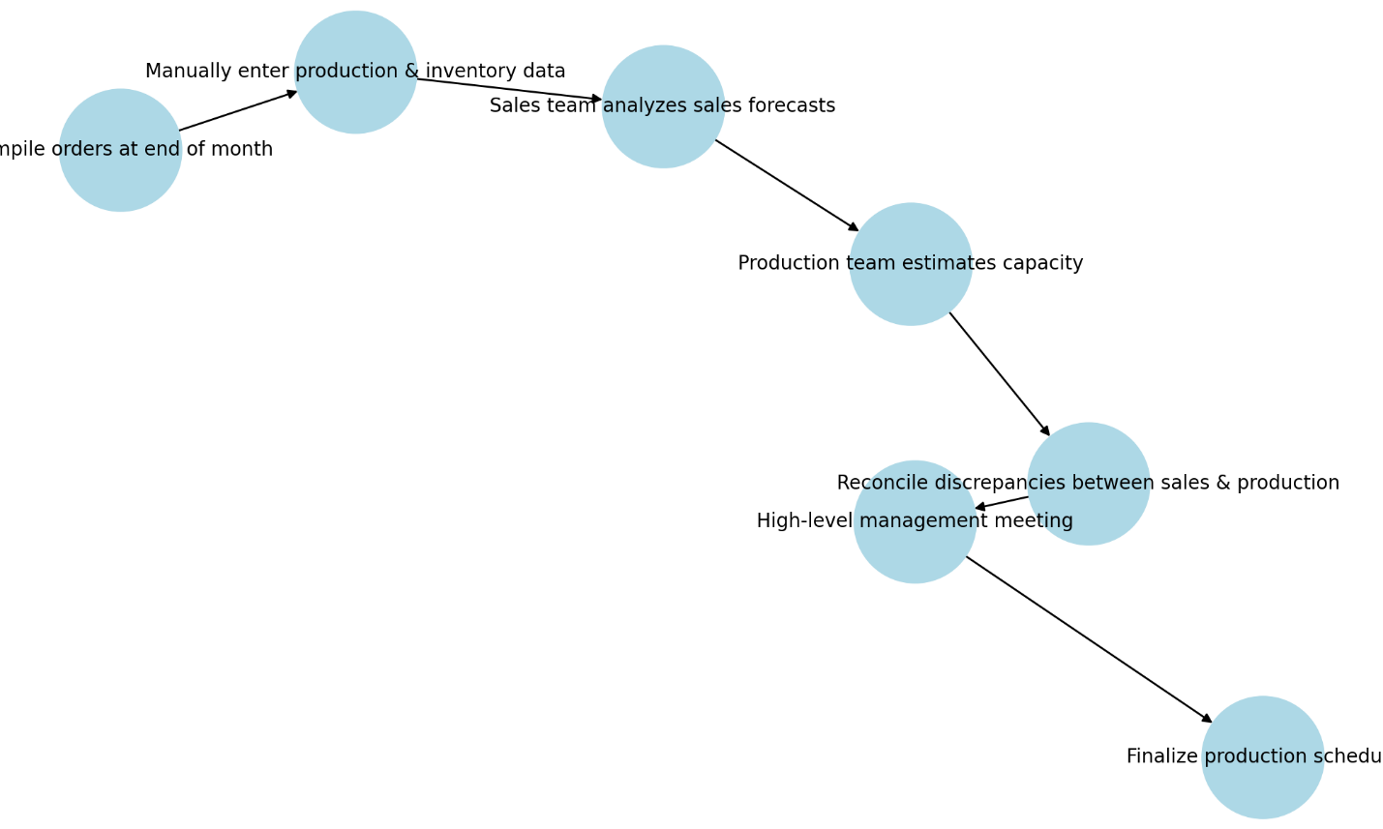

Figure 1: current_production_process

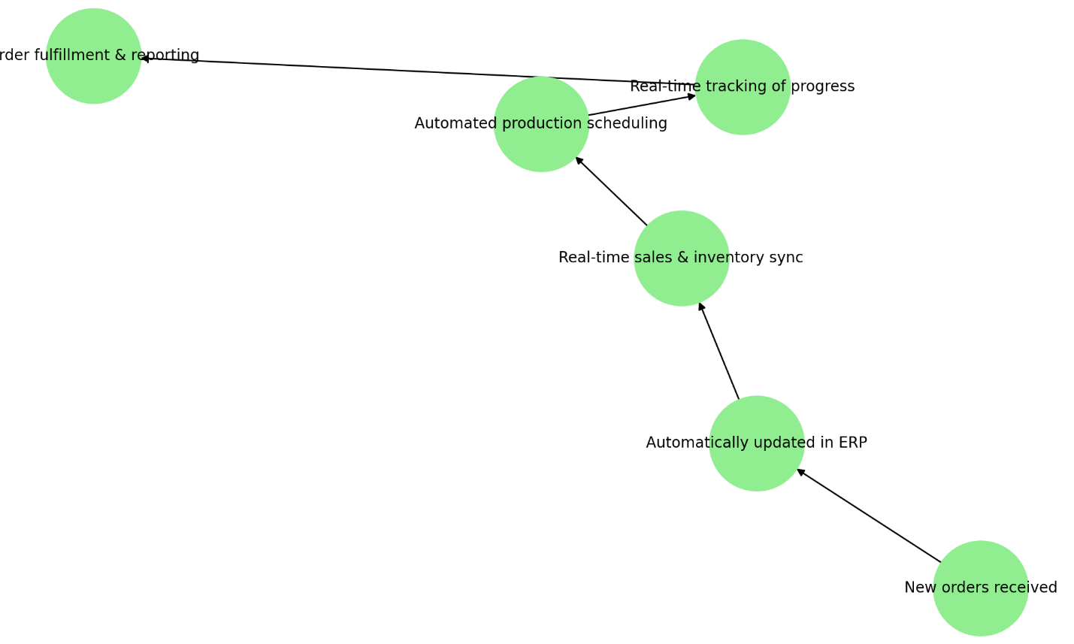

Figure 2: erp_production_process